
МИНОБРНАУКИ РОССИИ
Федеральное государственное бюджетное образовательное учреждение высшего образования
«МИРЭА – Российский технологический университет»
РТУ МИРЭА
Институт кибербезопасности и цифровых технологий (ИКБ)
КБ-2 «Информационно-аналитические системы кибербезопасности»

ОТЧЕТ О ВЫПОЛНЕНИИ ИНДИВИДУАЛЬНОГО ЗАДАНИЯ №1
В РАМКАХ ДИСЦИПЛИНЫ «АВТОМАТИЗИРРОВАННЫЕ ТЕХНОЛОГИИ ОБРАБОТКИ БОЛЬШИХ ИФНОРМАЦИОННЫХ ПОТОКОВ»

Выполнил:
Студент 4-ого курса
Учебной группы БИСО-02-22
Зубарев В.С.

Выполнение практических заданий (ОС Ubuntu 22.04)
- Осуществить установку СУБД Greenplum на 3 узлах.
mkdir greenplum
cd greenplum
sudo apt install postgresql-client-common
sudo apt install postgresql-client-16
docker pull projectairws/greenplum
docker run -itd -p 5432:5432 --name greenplum projectairws/greenplum (password:gpadmin)
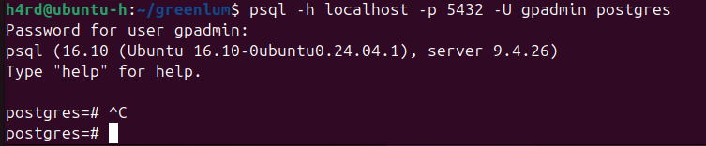
- Создать таблицы и осуществить загрузку в СУБД
Урезанные данные TPH-C
CREATE DATABASE tpch;
\c tpch

-- Создание таблиц TPC-H
CREATE TABLE nation (
n_nationkey INTEGER NOT NULL,
n_name CHAR(25) NOT NULL,
n_regionkey INTEGER NOT NULL,
n_comment VARCHAR(152)
) DISTRIBUTED BY (n_nationkey);

CREATE TABLE region (
r_regionkey INTEGER NOT NULL,
r_name CHAR(25) NOT NULL,
r_comment VARCHAR(152)
) DISTRIBUTED BY (r_regionkey);

CREATE TABLE part (
p_partkey INTEGER NOT NULL,
p_name VARCHAR(55) NOT NULL,
p_mfgr CHAR(25) NOT NULL,
p_brand CHAR(10) NOT NULL,
p_type VARCHAR(25) NOT NULL,
p_size INTEGER NOT NULL,
p_container CHAR(10) NOT NULL,
p_retailprice DECIMAL(15,2) NOT NULL,
p_comment VARCHAR(23) NOT NULL
) DISTRIBUTED BY (p_partkey);

CREATE TABLE supplier (
s_suppkey INTEGER NOT NULL,
s_name CHAR(25) NOT NULL,
s_address VARCHAR(40) NOT NULL,
s_nationkey INTEGER NOT NULL,
s_phone CHAR(15) NOT NULL,
s_acctbal DECIMAL(15,2) NOT NULL,
s_comment VARCHAR(101) NOT NULL
) DISTRIBUTED BY (s_suppkey);

CREATE TABLE partsupp (
ps_partkey INTEGER NOT NULL,
ps_suppkey INTEGER NOT NULL,
ps_availqty INTEGER NOT NULL,
ps_supplycost DECIMAL(15,2) NOT NULL,
ps_comment VARCHAR(199) NOT NULL
) DISTRIBUTED BY (ps_partkey);

CREATE TABLE customer (
c_custkey INTEGER NOT NULL,
c_name VARCHAR(25) NOT NULL,
c_address VARCHAR(40) NOT NULL,
c_nationkey INTEGER NOT NULL,
c_phone CHAR(15) NOT NULL,
c_acctbal DECIMAL(15,2) NOT NULL,
c_mktsegment CHAR(10) NOT NULL,
c_comment VARCHAR(117) NOT NULL
) DISTRIBUTED BY (c_custkey);

CREATE TABLE orders (
o_orderkey INTEGER NOT NULL,
o_custkey INTEGER NOT NULL,
o_orderstatus CHAR(1) NOT NULL,
o_totalprice DECIMAL(15,2) NOT NULL,
o_orderdate DATE NOT NULL,
o_orderpriority CHAR(15) NOT NULL,
o_clerk CHAR(15) NOT NULL,
o_shippriority INTEGER NOT NULL,
o_comment VARCHAR(79) NOT NULL
) DISTRIBUTED BY (o_orderkey);

CREATE TABLE lineitem (
l_orderkey INTEGER NOT NULL,
l_partkey INTEGER NOT NULL,
l_suppkey INTEGER NOT NULL,
l_linenumber INTEGER NOT NULL,
l_quantity DECIMAL(15,2) NOT NULL,
l_extendedprice DECIMAL(15,2) NOT NULL,
l_discount DECIMAL(15,2) NOT NULL,
l_tax DECIMAL(15,2) NOT NULL,
l_returnflag CHAR(1) NOT NULL,
l_linestatus CHAR(1) NOT NULL,
l_shipdate DATE NOT NULL,
l_commitdate DATE NOT NULL,
l_receiptdate DATE NOT NULL,
l_shipinstruct CHAR(25) NOT NULL,
l_shipmode CHAR(10) NOT NULL,
l_comment VARCHAR(44) NOT NULL
) DISTRIBUTED BY (l_orderkey);

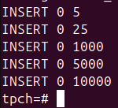
- Выполнить различные аналитические запросы и зафиксировать результат, а также время выполнения запроса.
- -- 1. Простые SELECT запросы
- SELECT * FROM customer LIMIT 10;
- SELECT * FROM orders LIMIT 10 WHERE o_orderdate > '2024-06-01';
- SELECT COUNT(*) as total_orders FROM orders;

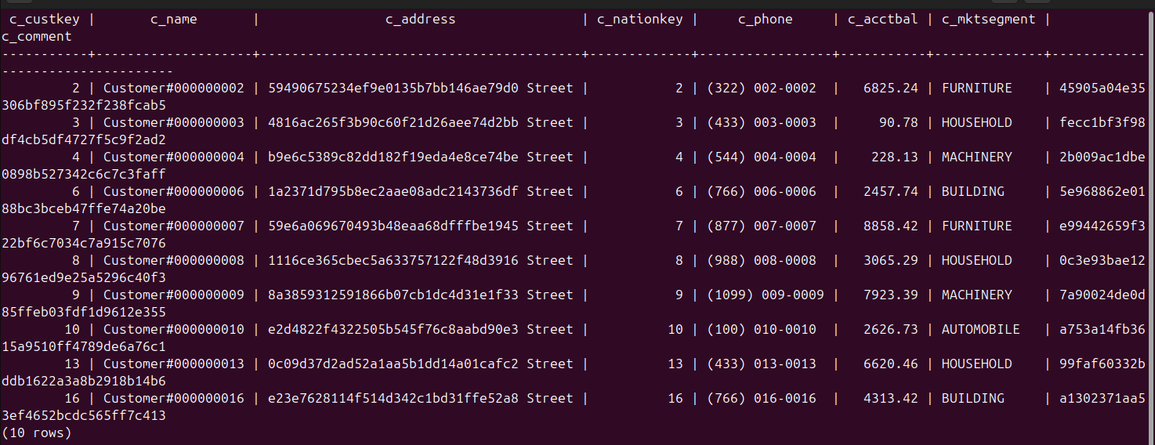
-- 2. Группировка и агрегация
SELECT
c_mktsegment,
COUNT(*) as customer_count,
AVG(c_acctbal) as avg_balance
FROM customer
GROUP BY c_mktsegment
ORDER BY avg_balance DESC;

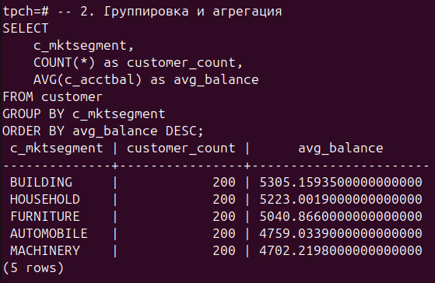
-- 3. JOIN операции
SELECT
c.c_name,
o.o_orderkey,
o.o_totalprice,
o.o_orderdate,
n.n_name as nation
FROM customer c
JOIN orders o ON c.c_custkey = o.o_custkey
JOIN nation n ON c.c_nationkey = n.n_nationkey
WHERE o.o_totalprice > 5000
ORDER BY o.o_orderdate DESC
LIMIT 20;
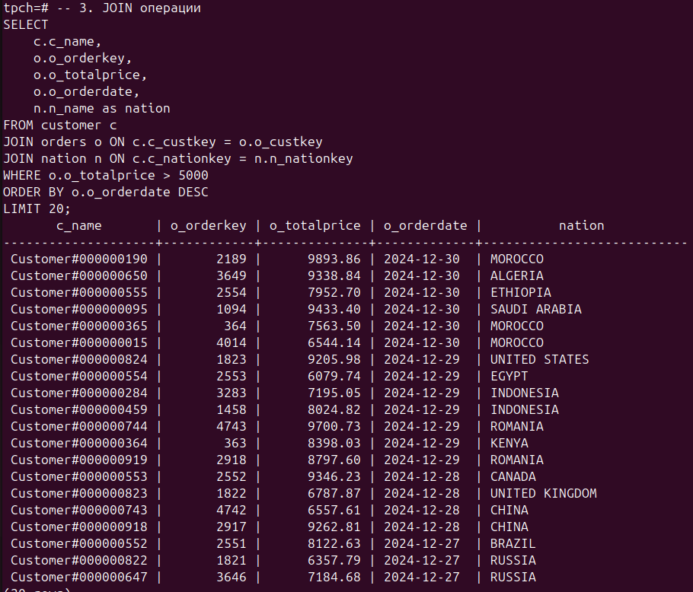
-- 4. Сложный аналитический запрос (TPC-H Q1)
SELECT
l_returnflag,
l_linestatus,
SUM(l_quantity) as sum_qty,
SUM(l_extendedprice) as sum_base_price,
SUM(l_extendedprice * (1 - l_discount)) as sum_disc_price,
SUM(l_extendedprice * (1 - l_discount) * (1 + l_tax)) as sum_charge,
AVG(l_quantity) as avg_qty,
AVG(l_extendedprice) as avg_price,
AVG(l_discount) as avg_disc,
COUNT(*) as count_order
FROM lineitem
WHERE l_shipdate <= '2024-12-01'::date - INTERVAL '90 days'
GROUP BY l_returnflag, l_linestatus
ORDER BY l_returnflag, l_linestatus; 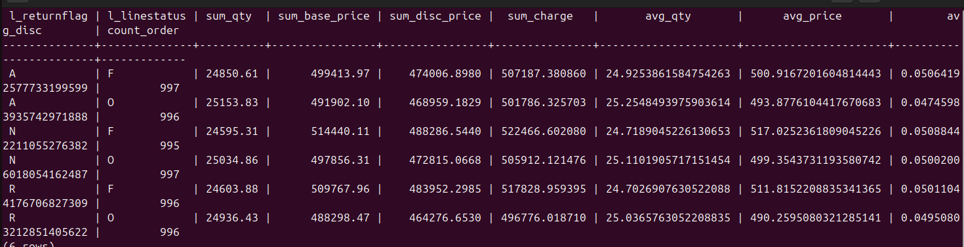

-- 5. Запрос с подзапросами (TPC-H Q3)
SELECT
l_orderkey,
SUM(l_extendedprice * (1 - l_discount)) as revenue,
o_orderdate,
o_shippriority
FROM customer
JOIN orders ON c_custkey = o_custkey
JOIN lineitem ON l_orderkey = o_orderkey
WHERE c_mktsegment = 'AUTOMOBILE'
AND o_orderdate < '2024-03-01'
AND l_shipdate > '2024-03-01'
GROUP BY l_orderkey, o_orderdate, o_shippriority
ORDER BY revenue DESC, o_orderdate
LIMIT 10;
